Data Preparation for Importing to SPSS
- Open the Data Converter and raw data files.
- Click anywhere on the shaded area of the spreadsheet and click on the Query Tools ribbon at the top.
- Click Edit on the far left of the ribbon.
- Click Data Source Settings on the far right of the ribbon.
- Click Change Source and select the raw data file.
- Click Close & Load.
- Open SPSS.
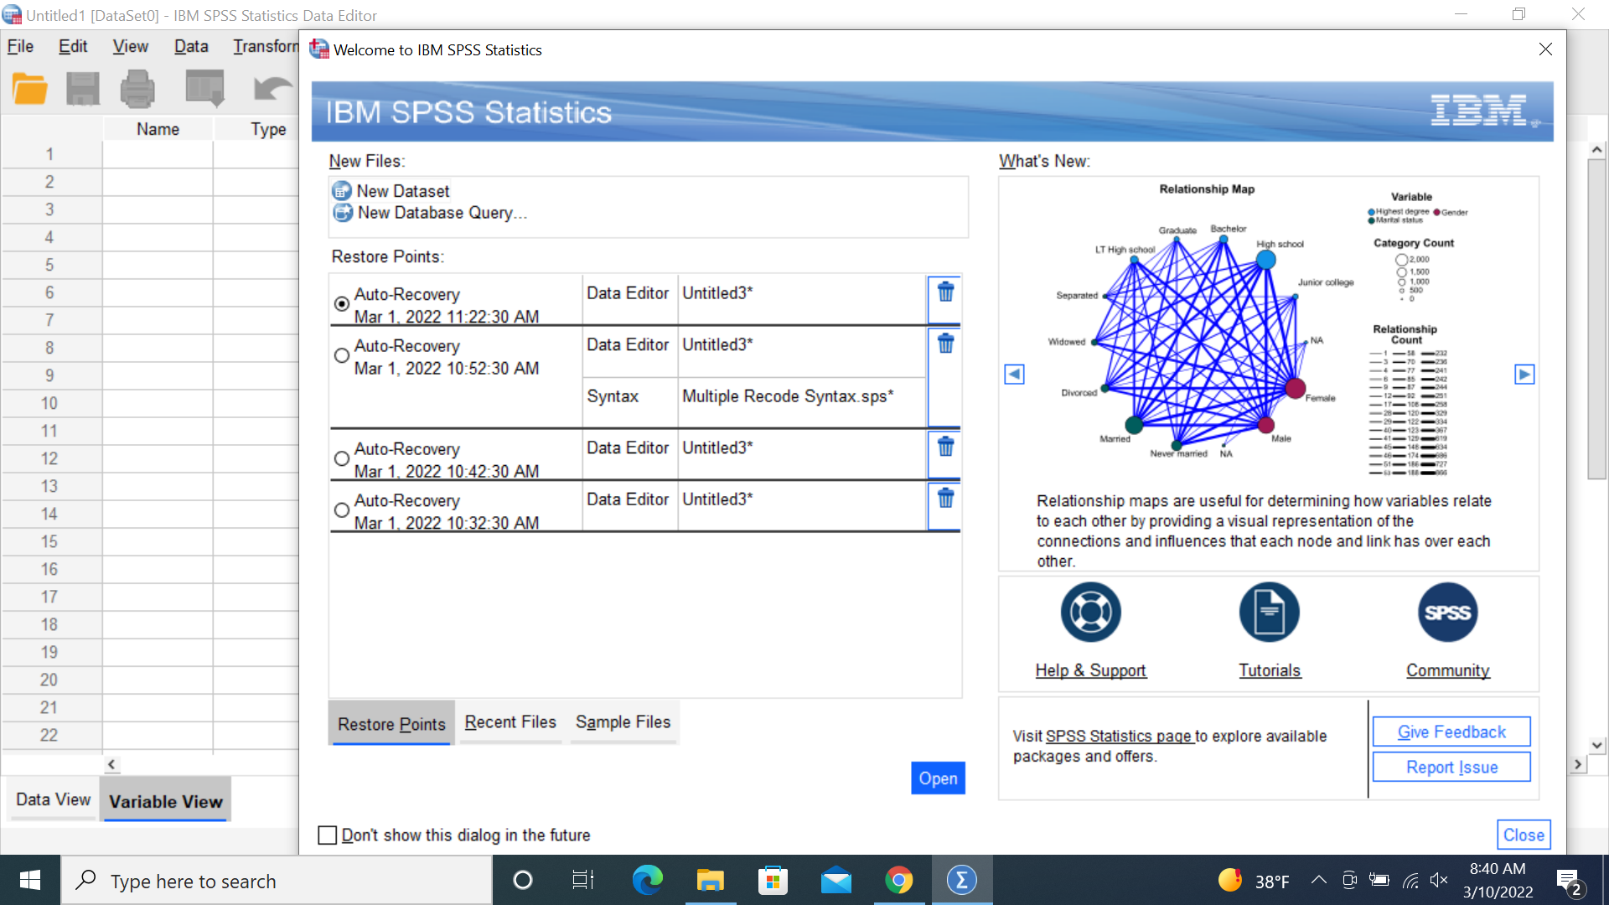
- Click New Dataset then click Open.

- Click File-> Import Data-> Excel

- Browse to the file and open.

